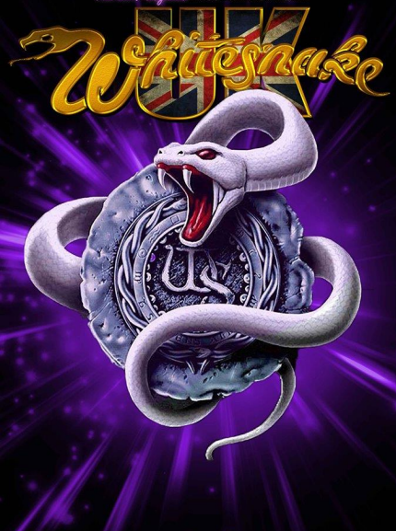
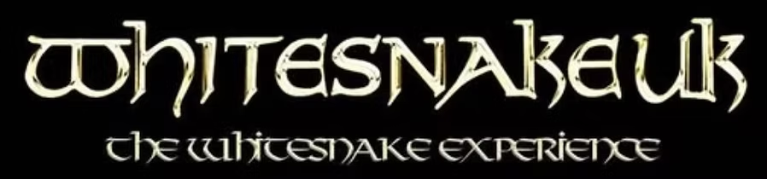
2025 PRESS AND INFORMATION
This press kit has been created to help venues, agents & promoters get to know more about Whitesnake UK, the live show, the band members & the band history.
Whitesnake UK are now firmly established as one of Europe's hardest working tribute bands with a large & very loyal following. This document is updated regularly to help act as a guide to familiarising yourself with Whitesnake UK

BAND BIOGRAPHY
Whitesnake UK play tribute to the very best of David Coverdale's multi platinum selling band, Whitesnake.
From the very beginnings of the Moody / Marsden line up to the current US led incarnation faithfully reproducing such timeless classics such as 'Fool For Your Loving', 'Don't Break My Heart Again', 'Is This Love', 'Here I Go Again' and many others.
With a band line up comprising professional recording artists who have shared stages with the likes of Kiss, Motley Crue, Saxon, Toto, Mr Big, Faith No More, Status Quo, Bon Jovi, Blur & Whitesnake themselves.
Including members from some of the world's most respected tribute bands, extensive worldwide touring from Europe to the USA and Japan to Australia, syndicated worldwide tv appearances, multiple features in the world's leading rock music publications & a combined musical experience of over one hundred and twenty years, Whitesnake UK can proudly boast to having some of the most accomplished personnel in any tribute band.
Formed in 2005, Whitesnake UK have performed extensively through the UK gaining a reputation for being THE tribute to Whitesnake whilst at the same time creating an unforgettable live show which has seen them play to sold out shows & festivals making them one of the hottest tribute acts currently working the UK circuit Whitesnake UK concentrate on reproducing that classic Whitesnake sound without the need for artificial backing tracks, gimmicks or wigs for that matter!
Having reformed in 2015 after a three year hiatus, Whitesnake UK are back stronger than ever, selling venues out across the country . Their extensive list of shows throughout 2023/4 (as well as being personally chosen by tribute giants, Live Wire.....the AC/DC show to be their special guests at their largest shows) just proves just how in demand they are.
Whitesnake UK won't be resting on their laurels any time soon though, Shows & festivals across Europe are already confirmed for 2025. Fully supported by past & present members of Whitesnake with a 110% live
An experience that will have you out of your seats dancing & shouting for more,.........Whitesnake UK are certain to deliver !
If Carlsberg did tribute bands....................................

Meet the band
On Vocals – Tim Reed
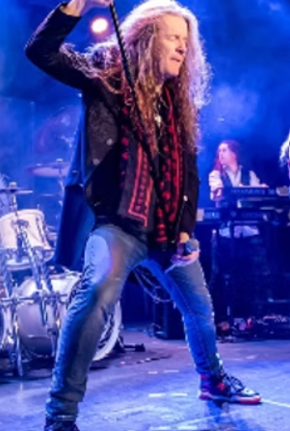
Tim has been fronting the exciting Syked, a tribute to the music of ex snake guitarist, John Sykes, however, before that he was a member of UK rockers, Chrome Molly, touring Europe with the likes of Alice Cooper & working with such music icons as Jim Lea of Slade.
Tim was also a member of New Wave Of British Heavy Metal luminaries, Demon, though most of you will know him for his decade long stint with Limehouse Lizzy. A veteran of over 1500 theatre & festival shows, Tim is also a music virtuoso & has just recently released his debut solo album entitled "Read Out Loud" to rave reviews including a four star award from Planet Rock Magazine who proclaimed it "A debut album to be reckoned with !" A lifelong Whitesnake fan, Tim brings a wealth of experience & a monstrous powerhouse vocal range to WSUK.
On Guitars – Craig Price & Greg Darby
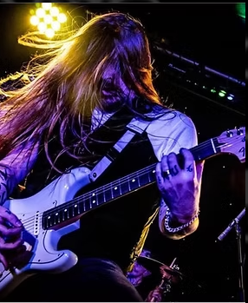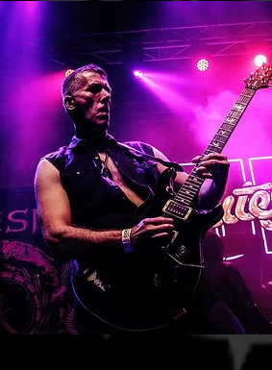
Guitarists, Greg Darby & Craig Price are as close knit a guitar duo as you'll find.
Complementing each other's styles with ease & finesse. From the bluesey early snake riffs to the all out thunder of latter day snake virtuosi Reb Beach, Vai, John Sykes, Doug Aldrich & now, Joel Hoekstra.
Replicating these top class players isn't an easy task but Craig and Greg accomplish this feat through years of musical dedication!
Both accomplished guitarists, Greg has extensive touring experience with cult band, King Rocker; whilst Craig has extensive touring experience in the world of tributes inc Limehouse Lizzy and original bands inc Iconic Eye.
Both guitarist continue to stretch their abilities to master the virtuosity of the full range of incredible players Whitesnake have had over their long history
Duncan Cook - Keyboards
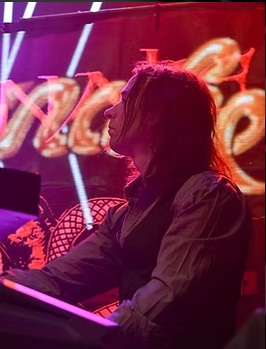
Ivory tinkler & all round gifted musician, Duncan Cook is the band's glue. Enhancing all eras of the snake's music with his smooth keyboard skills. From the likes of Wine, Women & Song, to the flowing power of Best Years, Duncan's keyboard wizardry will leave snake fans mesmerised.
Paul Thompson - Bass
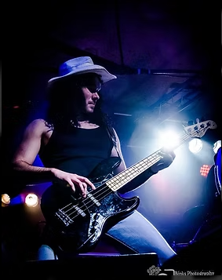
Taking care of the low end is Paul Thompson. Having travelled the world within the festival scene for the best part of a decade he is now the driving force of the rhythm section for WSUK. Taking influence from such musicians as Steve Harris and Geddy Lee he delivers a hard hitting performance every time.
Matt Blakout – Drums
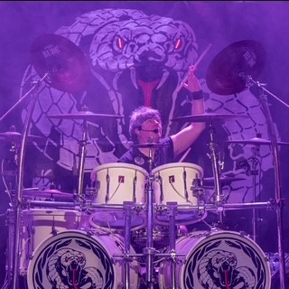
And last but by no means least....Every snake has a tail....& WSUK are extremely proud to have a tiger as its tail. Legendary Welsh glam rock icon, Matt Blakout from Tigertailz is the WSUK time keeper.
Visual and exciting to watch, Matt's experience & resume is even more impressive. Having played the world over and sharing the stage with the likes of Whitesnake themselves- and some of the most iconic names in music history- Matt commands everything from his drum stool.
Seeing is believing....and Matt never fails to deliver !

REVIEWS & COMMENTS
“Wow !! You guys are awesome” - Joel Hoekstra (Whitesnake / Cher)
“That Snake sound is really hard to nail down, but great job guys” - Doug Aldrich (Whitesnake / Dead Daisies / Dio)
“Absolutely loved them. Really good tribute band....and I don''t like many” - Steve Bebee (Kerrang! / Planet Rock)
“Absolutely brilliant chaps.....’’
David Coverdale
CONTACT
For more information please visit the Whitesnake UK website www.whitesnakeuk.co.uk
Follow us on Facebook : www.facebook.com/WhitesnakeUK
Follow us on Instagram : www.instagram.com/WhitesnakeUK
Follow us on Twitter : www.twitter.com/WhitesnakeUK
Whitesnake UK. All Booking enquiries can be made here: wsuktribute@gmail.com
Tel : 07745500322
