

WHITESNAKE UK TECHNICAL SPECIFICATIONS
This document has been put together to help with the smooth running of all WSUK shows, so that we, you and most importantly - the audience, have a great time !
This document is updated regularly when equipment is replaced but this should act as a standard for all shows.
For further technical information please contact :
Greg Darby – gregdarby@sky.com / 07446 941715
For any other aspects of this tech spec please contact :
Matt Blakout – 07745500322 / wsuktribute@gmail.com
Further marketing materials are available on request and on our website – www.whitesnakeuk.co.uk

STAGE DETAILS

DRUM RISER :
A standard 8ft x 8ft x 1ft is required, if available, in house. Please notify us if we need to supply our own.

KEYBOARD RISER :
A standard 3ft x 5ft (or similar) is required, if available, in house. Please notify us if this can be provided.

PROJECTION SCREENS & BACKDROP :
An integral part of our show is our lighted backdrop. A sufficient hanging bar is required for this purpose. We also use stage screens either side of the drum riser. Where restricted stage size determines we use smaller screens we will provide them.
Where projector screens are available (preferred) we have video introduction with audio which defaults to logo during the show.
An outro track is also required to be played for the final ‘bow’

AMPLIFIER STACKS :
Whitesnake UK do not use amplified backlines.
We position our IEM stage splitter system behind our stage screens where a backline would have been. (refer to stage plot)

SMOKE MACHINES :
When available, two smoke machines for ambient effect in parts of the show. These will be positioned at the far side of each stage screen.

IN EAR MONITORING SET UP
WSUK use their own portable splitter and in-ear monitor system for stage use. This is operated through our own in-ear mix with a set of outputs that we present to the in-house engineer to cable from, 16 channels that go straight to front of house mixer. WSUK will
cable the stage from the individual instruments to the splitter and manage the in-ear mix. It is possible to locate the splitter in an agreed convenient position on stage within reason due to cable lengths and quantities. (refer to stage plot)
It is also possible for us to cable from an in-house splitter if necessary. In this situation, the in-house engineer would be expected to cable the instruments etc to the in-house splitter and WSUK would then require a simple mapping of inputs (list) to cable to our mixer.

We provide our own boom mic stands & microphones for Drums and Lead and backing vocals

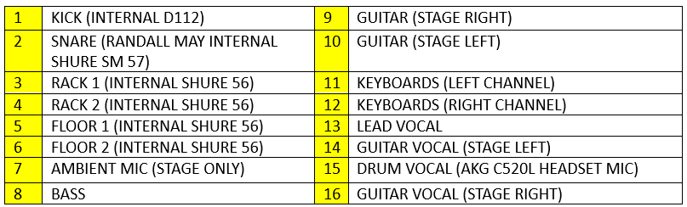
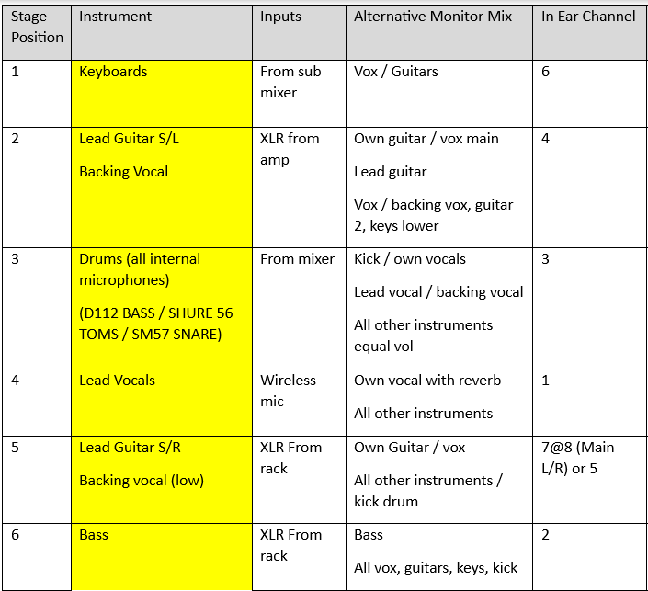

STAGE PLOT
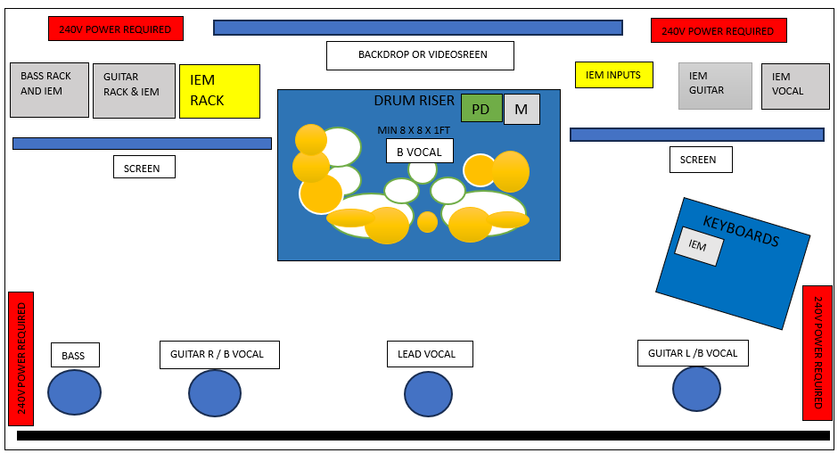

INTRO
Video or audio intro to be played on time
Stage black out with white search light type effect. Slowly flood the stage in blue as the band emerge and when Tim says “Are you ready ? - An outro track should be played on the final ‘BOW’

DRESSING ROOM :

A clean, dry, warm (or cool, weather dependant) secure dressing room with toilet facilities & secured mirrors is required We're far too old to get changed or try to relax in broom cupboards or storage areas anymore.....(a dressing room with a nice sea view would be very welcome).
Clean & dry towels

FOOD & DRINK :
coffee & tea, a fully working PAT tested kettle is vital !! Some clean mugs, fresh milk, sugar & spoons are helpful too. Bottled water only please, one small case is all we require for stage use.
Soft drinks such as 7up, Pepsi, Fanta, Red Bull are always nice.
hot food.
SECURITY :
Whitesnake UK's show is very high energy, especially toward the finale.
Stage encroachment not only unsettles the band but ruins the show for 99.9% of the audience

Any further information or clarification required, please ask, we are helpful and obliging chaps.
We hope you enjoy the show!



